

Smart Agriculture Crop Monitoring Platform

Course Name:Software Engineering
Course Code:CSA1004

Guided by:
Dr.Anitadavamani K

Presented by:

T.V.Sai Jagadeesh
192472146

Smart Agriculture Crop Monitoring Platform

1 Understanding the problem
This report proposes a small farm monitoring platform that helps farmers decide when to inspect crops and consider irrigation. Internet of Things (IoT) means physical devices that collect information and share it over a network. Here, connected sensors provide regular readings, while the farmer makes the final decision. The report describes a proposed design, not a completed implementation or measured field study.

Problem and practical example
Manual observation gives useful information, but conditions can change between field visits. A dry soil surface may hide moisture deeper near the roots, while one wet patch may not represent the whole field. Temperature and humidity can also change during the day. Relying only on visible symptoms may delay action until a crop is already under stress.
Consider a farmer growing tomatoes in three monitoring zones. The farmer normally waters every morning, but rain has left one zone wet while another is drying. The dashboard shows recent moisture trends for each zone. The farmer checks the dry zone physically and waters it if appropriate, instead of applying the same watering schedule everywhere.

Objectives
- Monitor soil moisture, air temperature, and humidity in each zone.
- Collect readings regularly and keep the time and source of every reading.
- Detect abnormal conditions and highlight readings needing inspection.
- Recommend when irrigation may be needed using valid moisture trends.
- Track crop growth through dated observations and measurements.
- Send clear alerts identifying the affected zone and suggested action.
- Maintain historical farm records for comparison over time.
- Generate reports summarising readings, observations, and alerts.

Scope and boundaries:
The first version covers one farm with several zones, registered crops, linked sensors, a web dashboard, rule-based recommendations, alerts, and downloadable reports. A student team can first test one sensor unit and then repeat the setup across the zones. Automatic disease diagnosis, guaranteed yield prediction, and fully automatic pump control are outside the initial scope.
Soil and environmental readings identify risk conditions; they cannot directly confirm disease. Crop growth will initially be recorded by the farmer using plant height, growth stage, written observations, and dated photographs. These records help explain changes that sensors alone cannot show.

People involved and their challenges:
Stakeholder | Role and responsibilities | Main challenges
Farmer | Reviews readings, checks fields, decides on watering, and records growth. | Clear advice and limited technical knowledge.
Farm workers | Inspect zones, water crops, and report visible problems. | Time for visits and consistent observations.
Agricultural advisers | Help choose thresholds and interpret crop risks. | Different soils, crop stages, and incomplete data.
Owner or manager | Approves costs and reviews resource use and reports. | Installation cost and uncertain financial benefit.
System administrators | Manage accounts, backups, and service availability. | Outages and protecting private farm records.
Developers and testers | Build modules, verify behaviour, and fix defects. | Incorrect readings and changing requirements.
Installation and maintenance personnel | Place, calibrate, clean, and replace sensors. | Sensor wear, power supply, and field access.
Unreliable internet may interrupt updates even when sensors are working. The screen must show when data was last received so that an old reading is not mistaken for a current one. Maintenance personnel need a simple checklist for placement and calibration. Farmers need messages such as “Check moisture in Zone 2” rather than unexplained numbers or technical error codes.

Existing process and its strengths:
Farmers commonly visit fields, feel soil by hand, follow a fixed irrigation schedule, and keep notes on paper. They may seek advice when leaf colour, wilting, or other visible symptoms change. This process has a low initial cost and uses local knowledge. Direct inspection can reveal damaged plants, blocked irrigation lines, and other problems outside the sensors’ coverage.

Limitations and gaps to address:
Visits provide occasional snapshots, so drying between visits can go unnoticed. Paper notes may omit dates or measurements, making it difficult to compare zones and seasons. Frequent visits take time, and a fixed schedule may continue after rainfall even when watering is unnecessary. Advice requested only after symptoms appear may arrive late.
The proposed platform addresses these gaps through regular readings, zone charts, timestamped records, and alerts. It helps the farmer decide where to inspect first. Farmer judgment remains necessary because a faulty probe, unusual weather, or a problem in an unmonitored part of the field can make a recommendation unsuitable.

Architecture and prototype components:
The information flow is: sensors → ESP32 microcontroller → internet connection → backend and database → recommendation engine → farmer dashboard and alerts. A soil moisture sensor measures a local soil condition; a temperature and humidity sensor measures surrounding air. Calibration relates sensor output to meaningful moisture values for the soil being monitored.
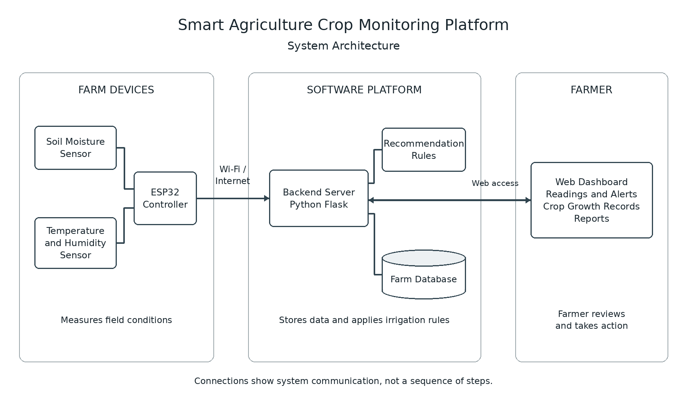
Fig.no:1
The ESP32 is a small programmable controller that reads sensors and transmits their values through Wi-Fi. It also acts as the gateway, or link between devices and the server. The Python Flask backend is the server program that receives requests, checks data, and controls access. SQLite stores records in a database file. A recommendation engine applies simple rules, and a web dashboard displays the results.
This combination suits a small prototype because the ESP32 supports Wi-Fi, Flask needs little setup, and SQLite avoids a separate database server. A basic mobile-friendly web page can show all three tomato zones without requiring a dedicated phone application.

Six functional modules:
Farm and user management stores crops, zones, users, and permissions. Sensor data collection and validation accepts readings, checks their format and limits, and flags suspicious values. Crop condition and growth monitoring combines charts with farmer-entered heights, growth stages, observations, and photographs.
Irrigation recommendations compare valid moisture trends with configured thresholds. Alerts and notifications show the affected zone, time, reason, and suggested inspection; dashboard alerts are sufficient initially. Historical records and reports let users review past conditions and export selected dates for discussion with an adviser.

Functional requirements:
- Provide login and allow authorised users to register fields, crops, and zones.
- Link each sensor to a zone and store timestamped readings with units and validation status.
- Display current conditions, freshness warnings, and charts for selected dates.
- Allow authorised users to configure crop and zone thresholds and receive alerts.
- Record dated crop observations, plant heights, growth stages, and photographs.
- Export reports containing readings, observations, and alert history for a chosen period.

Illustrative irrigation rule:
For illustration only, suppose calibrated moisture stays below 25% for three consecutive valid readings collected five minutes apart. The platform recommends checking that tomato zone and irrigating if appropriate. The percentage must have a defined calibrated meaning. An adviser should adjust thresholds for crop, soil, growth stage, and calibration; this is not a universal watering rule.
A basic moisture sensor alone cannot determine an exact irrigation volume. That calculation also needs information such as field area, root depth, soil water capacity, irrigation efficiency, and recent rainfall. The prototype therefore recommends an inspection and possible watering, not an exact quantity.
Non functional requirements:
Modularity separates collection, recommendations, alerts, and reports so a rule can change without rewriting sensor code. Scalability means supporting growth: each reading carries farm, zone, and sensor identifiers. If many users or simultaneous writes exceed the prototype’s needs, the team can replace SQLite with a server database such as PostgreSQL.
Maintainability means making changes safely through readable code, setup instructions, configuration files, and Git version control, which records changes. Reliability requires rejecting invalid readings, detecting duplicate messages, buffering readings locally during outages, showing stale-data warnings, and backing up records. Reconnected devices must preserve original measurement times.
Usability requires simple mobile-friendly screens, clear units, readable alerts, and possible local-language support. Security requires securely hashed passwords, role-based permissions, encrypted HTTPS connections, and a separate credential for each device. Farmers access their own farm data; only authorised managers or advisers can change thresholds. Device credentials should be replaceable if exposed.
Proposed acceptance targets, not achieved results: with readings scheduled every five minutes, show a stale warning after 15 minutes without updates; display a dashboard alert within 60 seconds after the server accepts a triggering reading; and store one record per unique sensor message after reconnection. These targets must be verified in prototype testing.

Agile with lightweight Scrum:
The Software Development Life Cycle (SDLC) covers requirements, design, development, testing, deployment, and maintenance. Agile performs this work in small stages and uses feedback to adjust priorities. Scrum organises Agile work into short cycles called sprints. A product backlog is an ordered list of needed features and fixes. Four proposed one-week sprints are:
Sprint | Planned work
1 | Requirements, interface design, and farm registration.
2 | Sensor integration, validation, and data storage.
3 | Monitoring, irrigation recommendations, and alerts.
4 | Reports, testing, user feedback, and improvements.
This approach suits uncertain sensor behaviour and changing farmer feedback. After each sprint, the team demonstrates working features, reviews feedback, tests changes, updates documentation, and revises the backlog. Recorded decisions and defect reports support later maintenance. A fixed sequential Waterfall approach is less flexible here because late discoveries may require revisiting earlier design stages.

Meaningful tests:
Submit missing values and out-of-range readings: flag or reject them without triggering irrigation advice. Disconnect Wi-Fi: buffer data, show the stale warning, and avoid duplicates on recovery. Test three low readings and an interrupted sequence: alert only when the rule is met. Attempt another farm’s records and unauthorised threshold edits: deny access. Compare an exported date range and totals with stored records: require an exact match.
Expected benefits and evaluation:
These benefits are expected possibilities, not proven outcomes. Zone-specific trends can improve irrigation efficiency by showing where moisture is falling. In the tomato example, the farmer may avoid watering the wet zone after rain, reducing unnecessary watering and potential water wastage. Alerts about unusual heat, humidity, or moisture can encourage earlier inspection of unfavorable growing conditions.
Historical reports support better resource management by showing which zones repeatedly need attention. Growth observations beside sensor charts help farmers and advisers make more informed decisions. Timely action may improve productivity, but the system cannot promise a yield increase. Crop variety, soil condition, pests, and farming practices also influence results.
A field evaluation could compare measured water use over similar periods, accounting for rainfall, crop stage, and area. Irrigation actions should be recorded so changes can be explained. Alert delivery time can be measured from accepted reading to displayed alert. Data completeness is the share of scheduled readings successfully received. Farmer feedback can assess whether messages are understandable and recommendations useful. Productivity claims require a separate field comparison.

Risks and practical mitigations
Risk or limitation | Practical mitigation
Drift, poor placement, or calibration errors | Check probes regularly, place them at suitable root depth, and compare readings with field checks.
Network outages and power failures | Buffer readings, show missing-data warnings, and use suitable backup power where feasible.
Hardware cost and maintenance | Begin with a few zones, estimate replacement costs, and maintain a service checklist.
Different crops, soils, and unsuitable thresholds | Configure each zone with adviser input; review repeated false alerts and tune rules.
Too few sensors and limited coverage | Place sensors in representative areas and retain physical inspections of uncovered areas.
Environmental readings cannot independently diagnose disease. An alert should state the observed risk and request inspection rather than name a confirmed disease. Actual productivity improvements remain uncertain until field evaluation. Missing or invalid data should reduce confidence in recommendations instead of being treated as evidence that the crop is healthy.

Future enhancements
Later versions could add local-language interfaces and weather forecasts to make advice easier to understand and account for expected rain. Solar-powered devices and better field connectivity could reduce interruptions. Image-based crop health analysis would require suitable labelled images and separate validation. Irrigation automation should be introduced only with manual override, pump safety controls, and a safe response to missing data.

Conclusion
The proposed platform gives farmers regular zone information, understandable recommendations, and a record of crop conditions. Keeping the first version to one farm, basic sensors, simple rules, and a web dashboard makes it achievable for a student team. Its usefulness depends on reliable measurements and farmer inspection, which the design supports throughout.

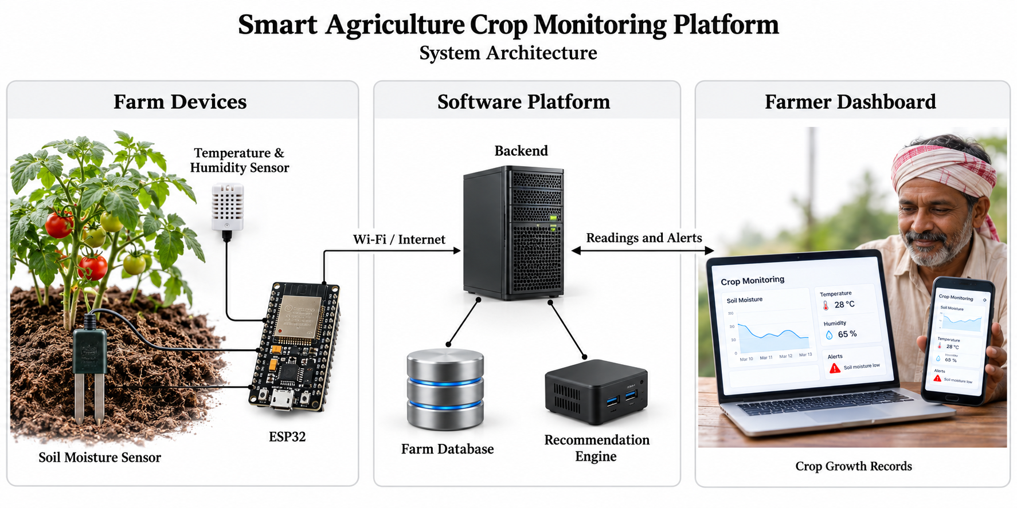
Fig.no:2

IN JIRA

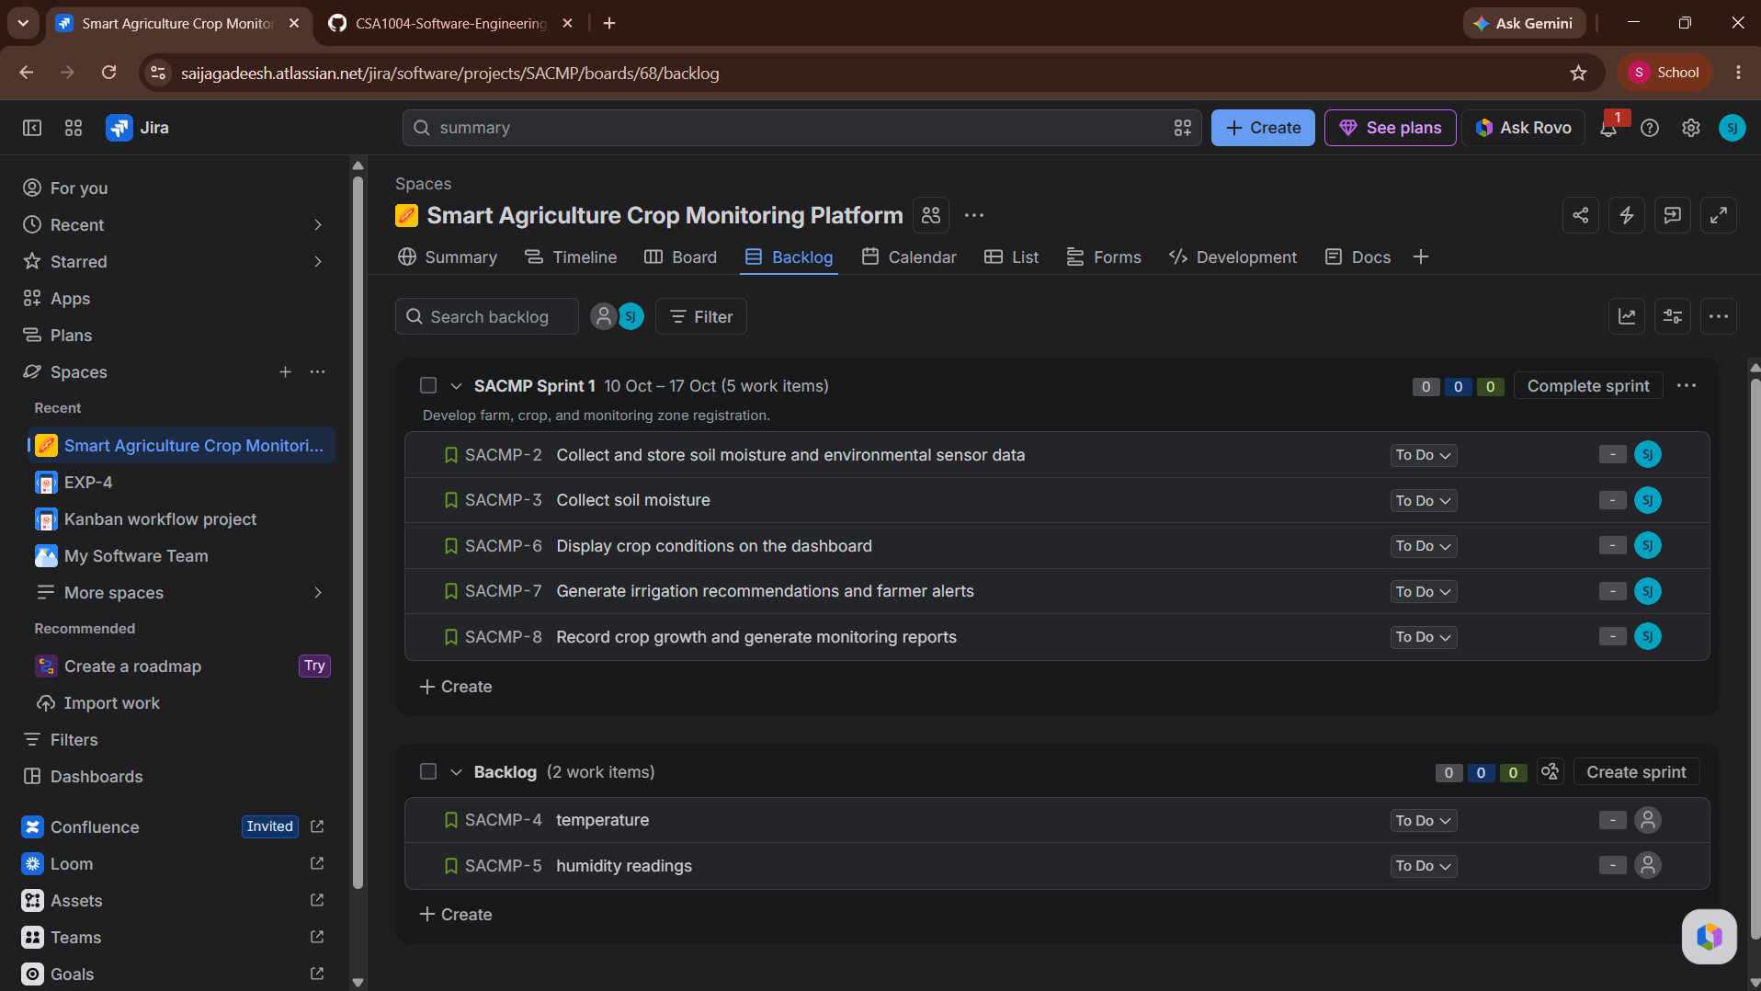
Fig.no:3

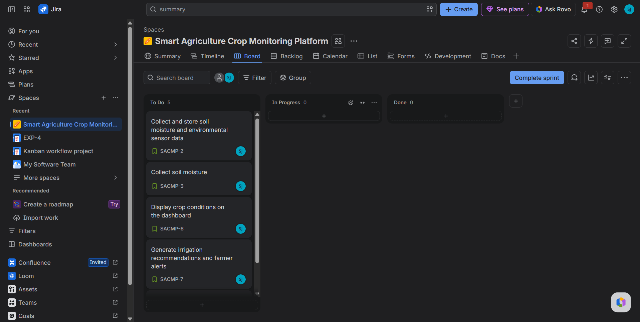
Fig.no:4

